India tour 14-30 November 2018
Hotel day 15
Wednesday 28th November 2018
Days 15 Agra, second hotel in Agra - ITC Mughal Taj Ganj Agra Utta Pradesh.
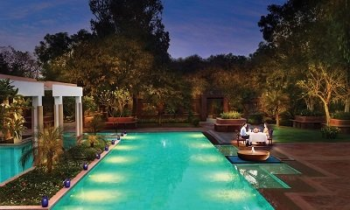
Exclusive swimming pool lit up at night.

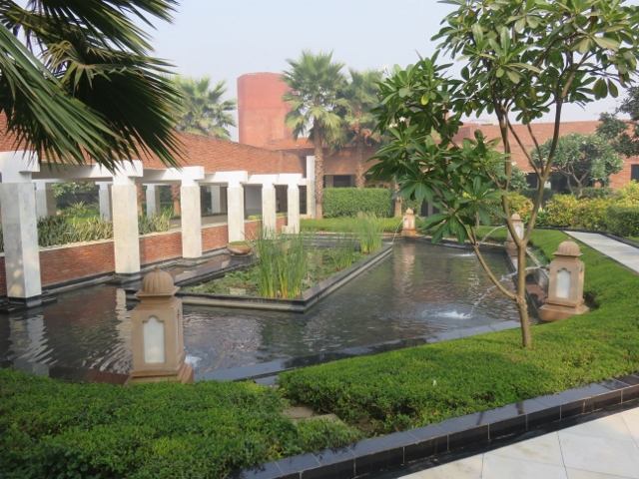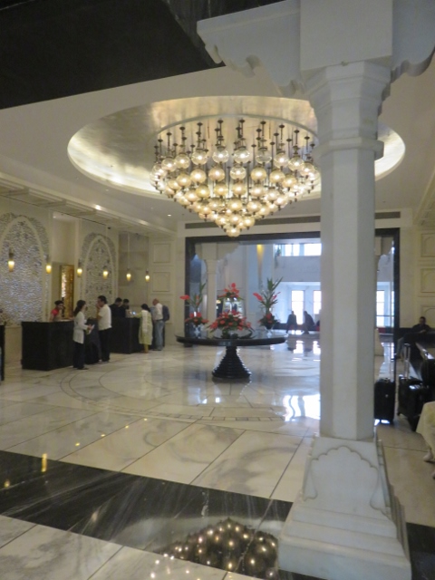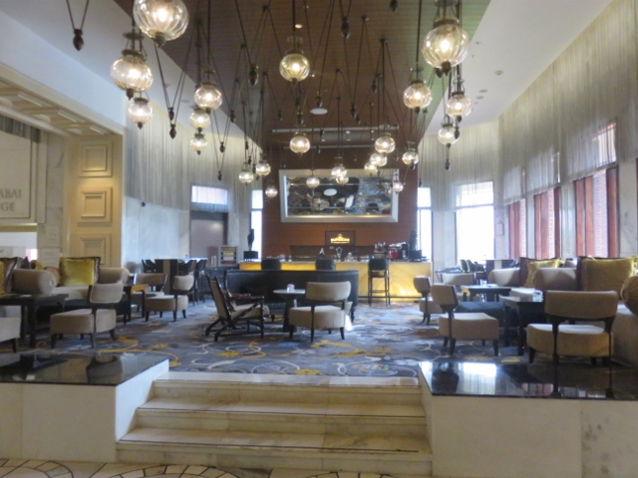
Main entrance walkway reception area & chandelier reception lounge area.

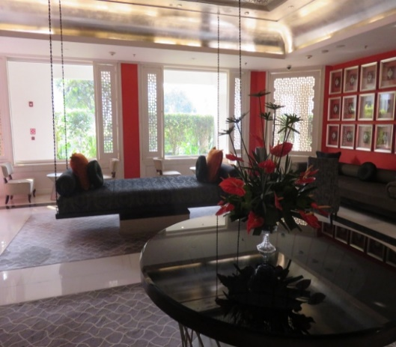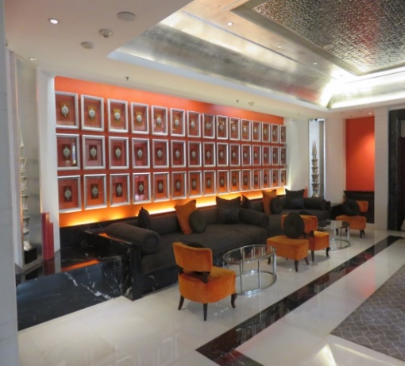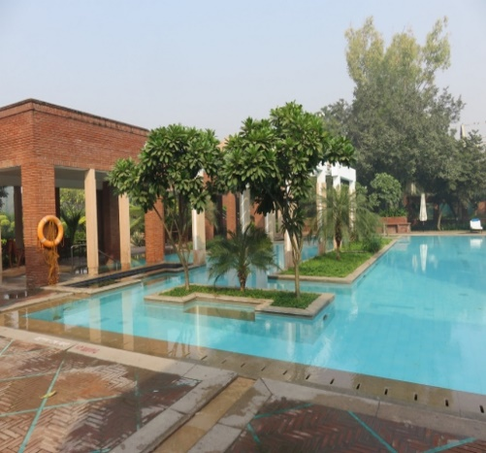
Suspended lounge setee relax area near bar exclusive swimming pool.

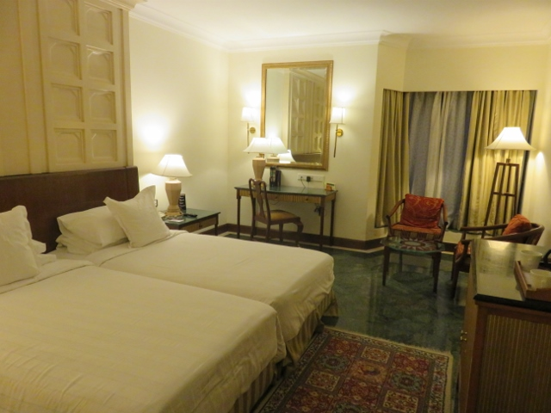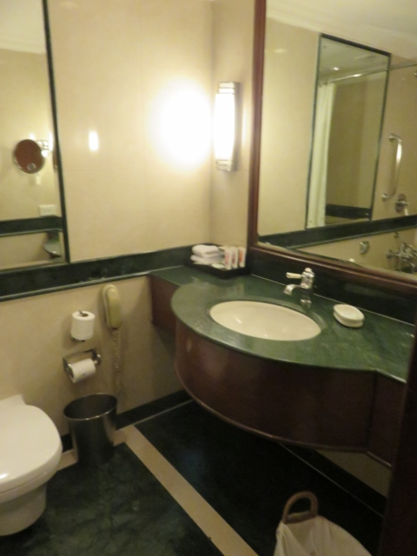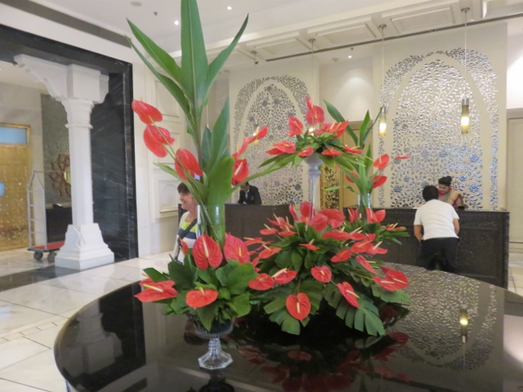
Alan’s bedroom very spacious green marble bathroom flower display in foyer.
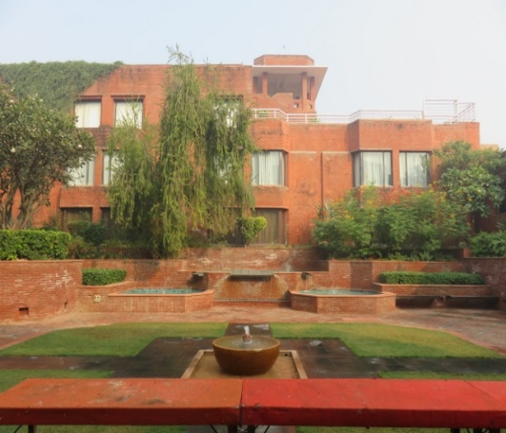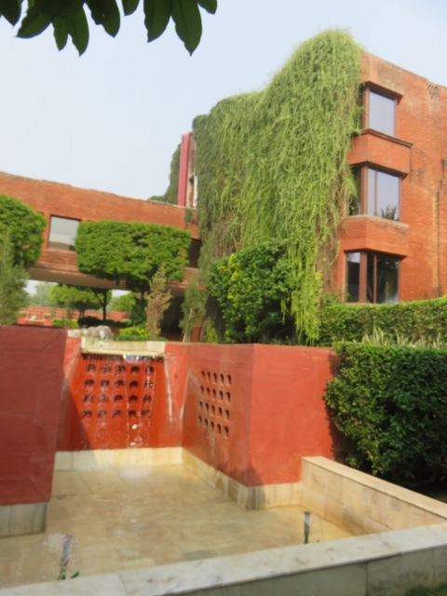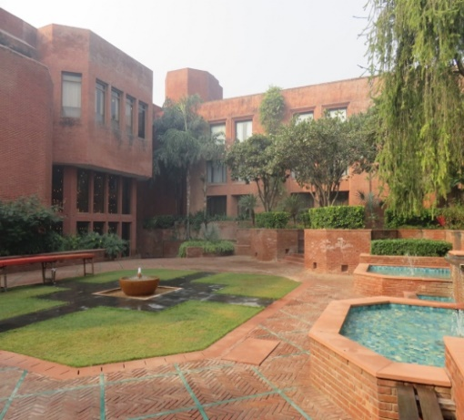
Red sandstone building like a fort another red sandstone courtyard pool and garden area.
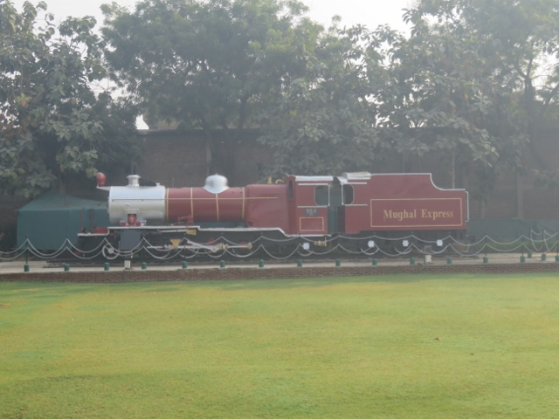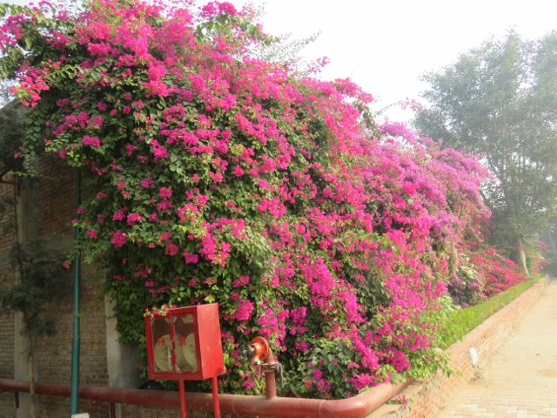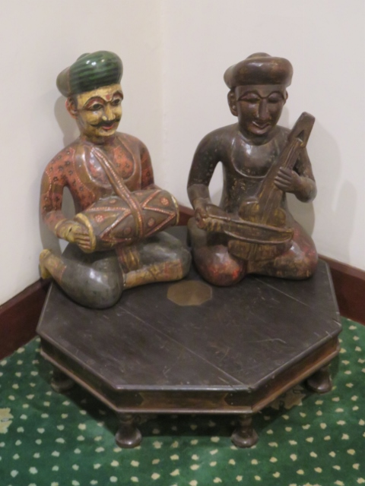
Railway steam engine in garden bougainvillea wall in garden sculptured musicians in hallway.

The Indian Tour Company had made a blooper in that they had not booked the tour group for a second night at the Trident Hotel in Agra. Consequently when the group returned to the Trident after sightseeing for the day an announcement was made to pack up our gear and head to the reception area for a move to another hotel as the Trident was fully booked. When Alan returned to his room, the hotel cleaning staff were doing the finishing touches to the room. He had to hurriedly pack everything up and scadattle out to the reception area.
The ITC Mughal Hotel was the replacement for the last night‘s stay in India. It took about 6 minutes’ drive in the bus from the Trident to the ITC Mughal hotel.

